Weather App

Environment: Node.js, PUG templating engine, MongoDB, Ajax , (GET,POST,DELETE) for RESTful Services, Open weather API

Initially When No cities are added in to the database:

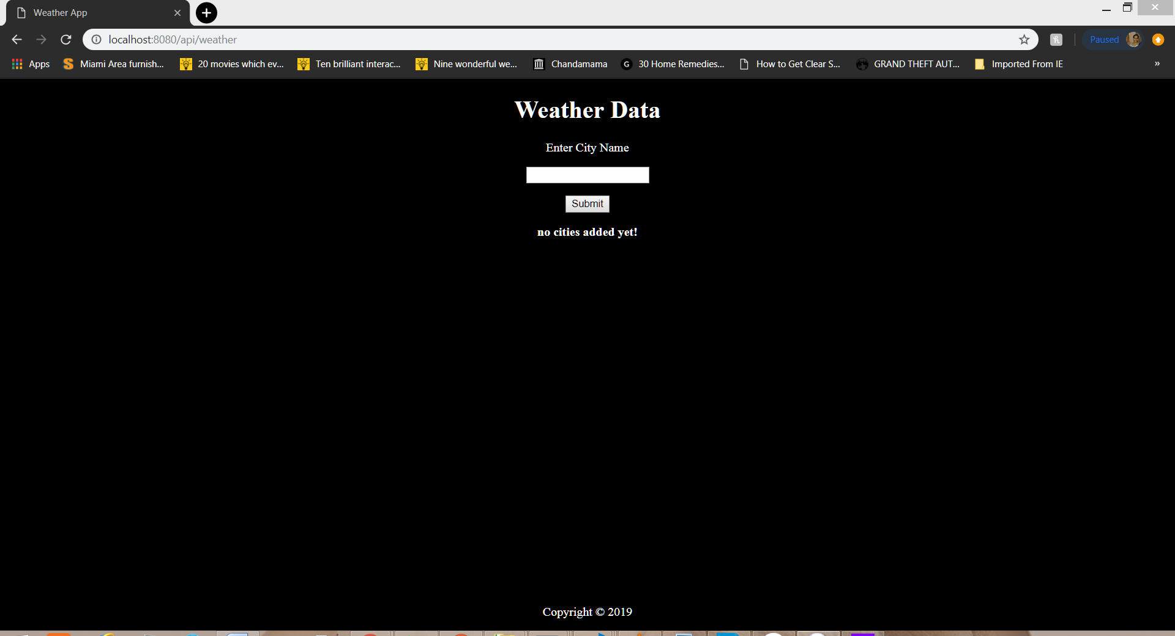

We can add any number of cities. Used Flex to align when more than one city is displayed on the page:

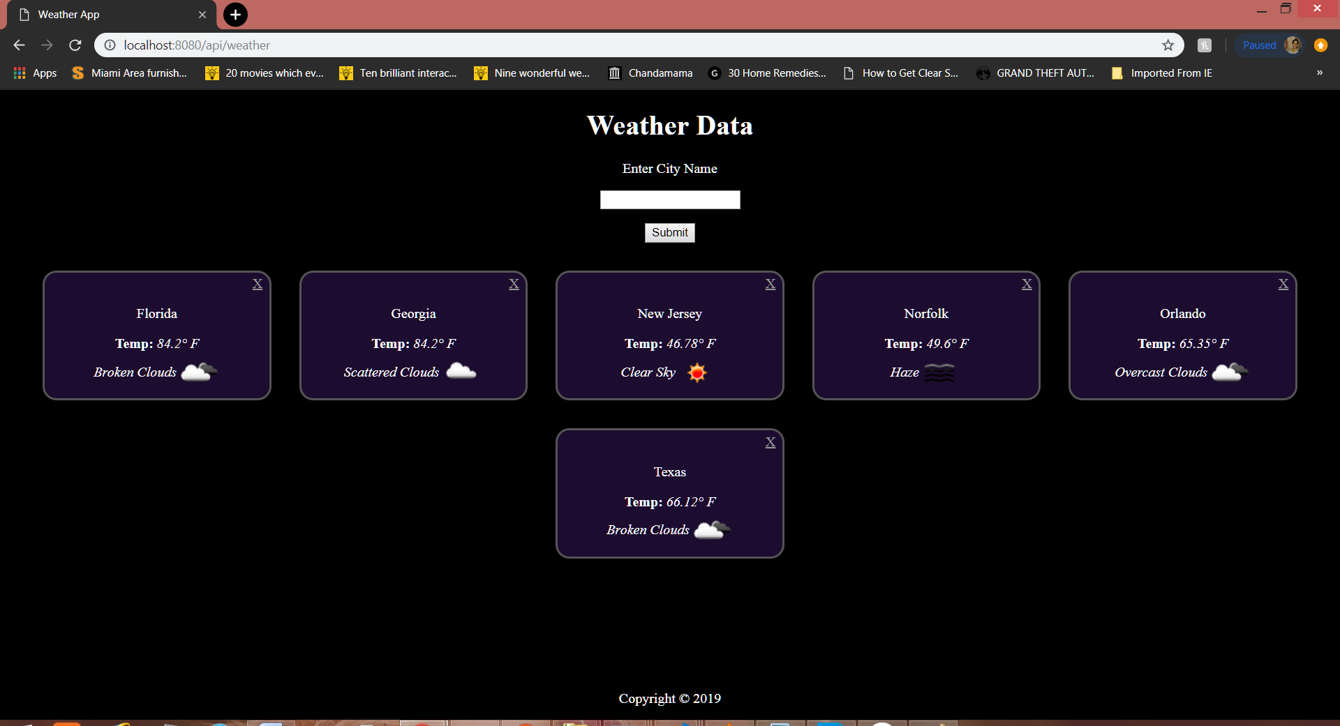

We can delete any city by clicking the “X” button on the city div.

Applied a hover effect, the button is highlighted when we hover over a city.

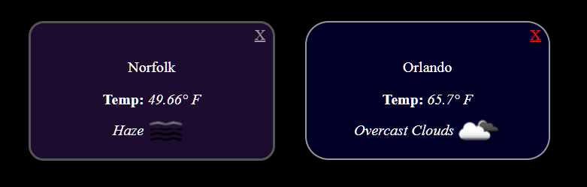

Validation and error messages:

Error messages when invalid city / wrong input which don’t match the validations:

Error message when an existing city is entered

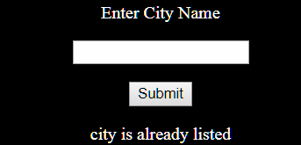

Error message when a wrong spelling or random text is entered

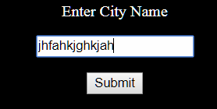 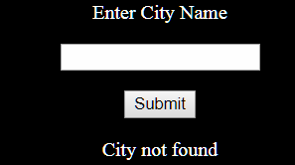

Error message when Invalid input:

1. Empty String or string less than length 3
2. Numbers in the string

